Collision Carts and Conservation of Momentum
The momentum of an object is the product of its mass and its velocity.
p = m v
The bold letters are used above to convey that momentum, represented by the p, is a vector. In addition to the momentum of a single object, one can consider the momentum of a "system" -- a combination of related objects.
P = p₁ + p₂ + ... = m₁ v₁ + m₂ v₂ + ...
The quantity P is useful because it is conserved (does not change with time) under certain circumstances. The circumstances are when there is no net external force on the system.
F_{net,ext} = 0
By "external" we mean forces exerted by bodies that are not part of the system on bodies that are part of the system. The claim is that internal forces, forces exerted by one body in the system on another, do not affect P, the momentum the system.
- The masses of the Carts (you should have one cart with a green sticker and the other without) and two metal blocks are roughly 500 g each. Your collision cars should have ends with Velcro patches.
- Set up a motion sensor at the end of a track (yellow plug in Digital Channel 1, black into Digital channel 2). In Data Studio, click on the image of Digital Channel 1 and choose Motion Sensor. On the middle right-hand-side of Data Studio, chose the Sample Rate to be 20 Hz.
- Place Cart 1 approximately 50 cm from the end of the track with the motion sensor and Cart 2 down the track. Have more distance between Cart 1 and Cart 2 than between Cart 2 and the end as shown below.
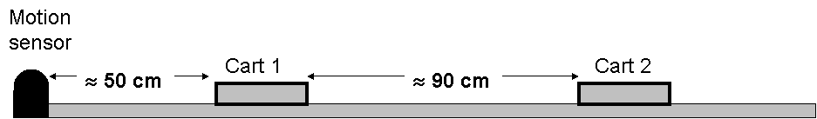
- The Velcro ends should be facing each other, so that the carts will stick together when they collide.
- Start recording and give Cart 1 a quick push.
- Our analysis will be based on the assumption that the carts stick together. Throw out the run if this was not the case.
- Under the Measurements tab at the bottom middle of Data Studio, chose Velocity.
- Double click on Graph under Displays on the lower left-hand-side of Data Studio and choose the desired Run from the dialog box.
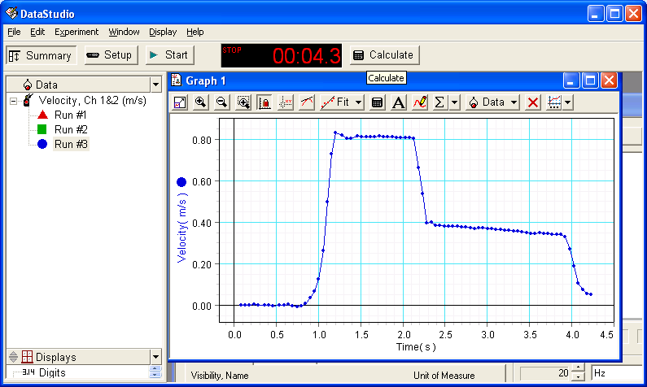
- In the graph above the region from 0 to 0.8 seconds is “before the push”; from 0.8 to 1.3 is “the push”; from 1.3 to 2.1 is “after the push and before the collision”; from 2.1 to 2.3 is “the collision”; from 2.3 to 3.8 is “after the collision”; and after 3.8 is “stopping.”
- Use the so-called “Smart Tool” to find the (time, velocity) pair just before the collision. Time is 2.1329 s and velocity is 0.80 m/s in the example below.
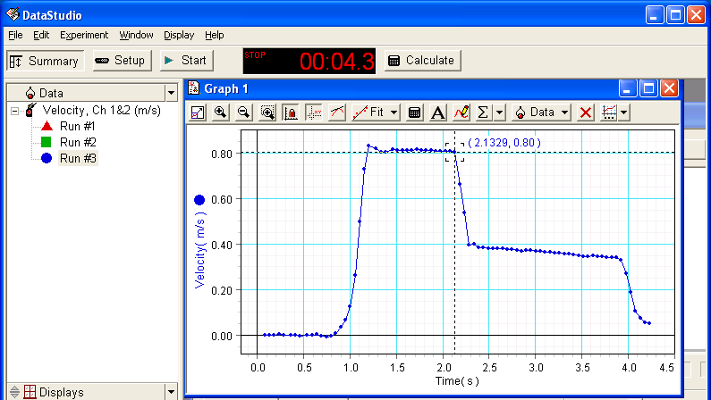
- Enter the velocity before the collision in the table below.
- Find the velocity just after the collision (0.40 m/s in the example below).
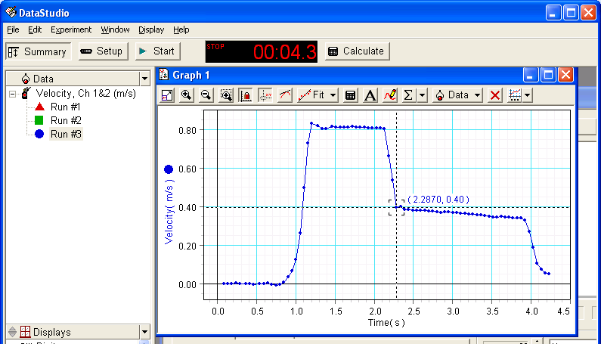
- Make a screen capture like the one above to include in your report. If you hit the Print Screen key at the upper right-hand-side of the keyboard, it places an image of your screen in the clipboard which can then be pasted into Word (or similar application). If you hold down the Alt key (lower left-hand-side of keyboard) while pressing the Print Screen key, you will capture only the highlighted item. Word has a Picture toolbar that will allow further editing such as cropping.
- Calculate the momentum of Cart 1 just before the collision (multiply mass of Cart 1, including the masses of any blocks in Cart 1, by the velocity). Similarly calculate the momentum of Cart 1 just after the collision. Also calculate the momentum of Cart 2 just after the collision. Enter them in the table provided below.
- Calculate the momentum of the system just before and just after the collision as well as the percent difference and enter them in the table provided below.
Repeat the measurements and calculations for the following cases:
- Trial 2: add one block to Cart 1.
- Trial 3: add a second block to Cart 1.
- Trial 4: remove the blocks from Cart 1; add one block to Cart 2.
- Trial 5: add a second block to Cart 2.

Velocities
trial | Velocity before  Cart 1 (m/s) | Velocity after  Carts 1 & 2 (m/s)
1
2
3
4
5

Individual momenta
trial | Momentum before  Cart 1 (kg m/s) | Momentum after  Cart 1 (kg m/s) | Momentum after  Cart 2 (kg m/s)
1
2
3
4
5

Momentum of the system
trial | Momentum before  System (kg m/s) | Momentum after  System (kg m/s) | Percent difference
1
2
3
4
5

Recall that another way of writing F=ma is F=∆p/∆t – the rate of change of momentum. Measure the duration of the collision (the difference between the time just before the collision and just after) and your momentum data to determine the rate of change of momentum on each cart.
trial | Duration  of Collision  (s) | Rate of change  of momentum  Cart 1 (N) | Rate of change  of momentum  Cart 2 (N)
1
2
3
4
5

The rate of change of momentum on Cart 1 should be from the force on it due to Cart 2. Similarly the rate of change of momentum on Cart 2 should be from the force on it due to Cart 1. Furthermore, these should be “equal and opposite actions”. Does your data support this? What is the name of this?
Identify the external forces on the two-cart system. Do you observe the effect of any of them in your data?

