Honors 164 | Names: ___________________________

Some equations
$$F=\text{ma}$$ | $$a=\frac{v^{2}}{r}$$ | $$E=\frac{1}{2}{\text{mv}}^{2}$$
$$E=\text{mgh}$$ | $$S=−\sum_{i}{p_{i}{\text{log}}_{2}(p_{i})}$$ | $$C={\text{log}}_{2}N$$
$$F=k\frac{q_{1}q_{2}}{r_{\text{12}}^{2}}$$ | $$F=\frac{{\text{ke}}^{2}}{r^{2}}$$ | $$E=\frac{{\text{ke}}^{2}}{r}$$
$$E={\text{mc}}^{2}$$ | $$E=\text{hf}$$ | $$\text{mvr}=nℏ$$
$$R_{\text{eq}}=R_{1}+R_{2}$$ | $$\frac{1}{R_{\text{eq}}}=\frac{1}{R_{1}}+\frac{1}{R_{2}}$$ | $$V=\text{IR}$$
$$v=fλ=λ/T$$ | v=(Tension/µ)^{1/2} | C=2πr  A=πr²
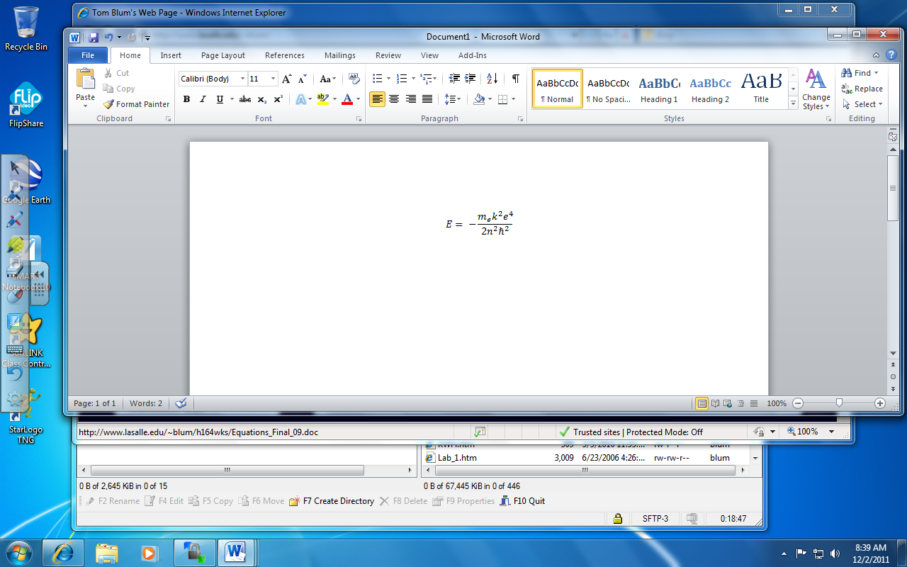 | 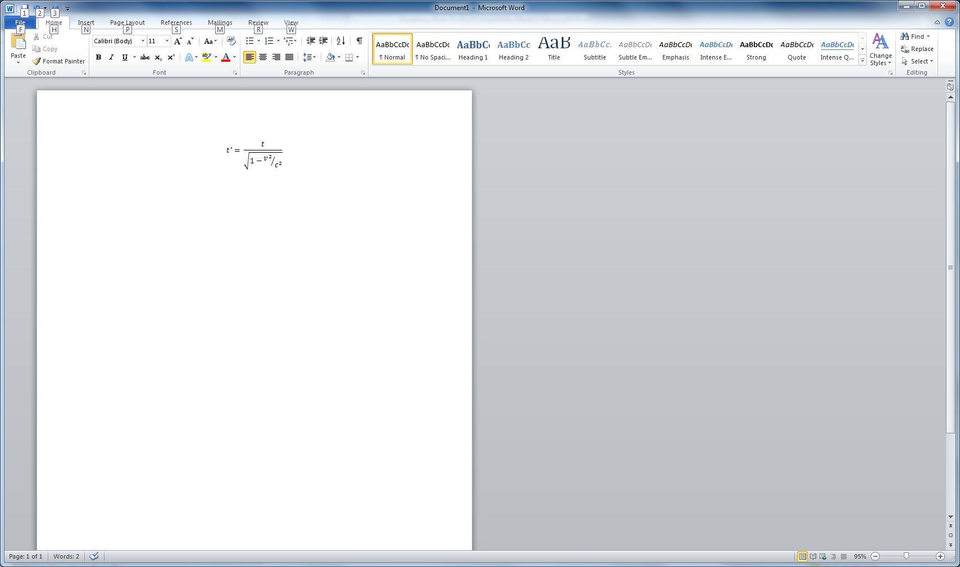 | P_{before}  =m₁v₁+m₂v₂ + …  =P_{after}  = m₁v₁’+m₂v₂’ + …
g = 9.8 m/s² | $$k=8\text{.}\text{99}×{\text{10}}^{9}{{\text{Nm}}^{2}}/{C^{2}}$$ | $$e=1\text{.}\text{602}×{\text{10}}^{−\text{19}}C$$
$$c=3\text{.}\text{00}×{\text{10}}^{8}m/s$$ | $$h=6\text{.}\text{63}×{\text{10}}^{−\text{34}}J⋅s$$ | $$ℏ=1\text{.}\text{05}×{\text{10}}^{−\text{34}}J⋅s$$
$$m_{e}=9\text{.}\text{11}×{\text{10}}^{−\text{31}}\text{kg}$$ | $$m_{p}=1\text{.}\text{67}×{\text{10}}^{−\text{27}}\text{kg}$$ | 1 mm = 1 × 10⁻³ m
1 μm = 1 × 10⁻⁶ m | 1 nm = 1 × 10⁻⁹ m | - km = 1 × 10⁺³ m

Calculate the n=1 and n=4 energy levels for Hydrogen.

What is the frequency of light that arises when the electron goes from the n=4 to n=1 level? What is the corresponding wavelength?
Perform a frequency analysis on the following joke.

He who laughs last thinks slowest.

Ohms Law and combinations of resistors

Series or Parallel?
Equivalent Resistance:
Current:
Power:

Series or Parallel?
Equivalent Resistance:
Current:
Where does the energy we put into this system go?

A .350-kg bob of a .450-m long pendulum is raised .150-m above its lowest point and released. Use conservation of energy (gravitational potential energy converting to kinetic energy) to find its velocity at its lowest point.

What would be the centripetal acceleration of the above pendulum bob at its lowest point?

What is the energy of a photon of light with a wavelength of 320 nm?

The B string of a certain guitar has a length of 58.5 cm (the “fundamental” wave has no internal nodes –
only nodes at the two ends). It vibrates at 247 Hz.
  - What is the speed of a wave on the string?
  - If the linear mass density of the guitar string is 0.0115 g/cm, what tension is required for the string to be in tune?

Bohr used quantization of angular momentum and found that the lowest state of Hydrogen (n=1) has a radius of 5.29 × 10⁻¹¹ m (the Bohr radius). What would he say was the corresponding velocity? How does that velocity compare to the speed of light?

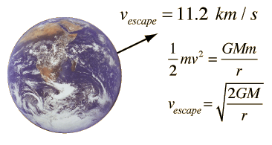
What is the escape velocity for the moon? (Radius: 1737.5 km, Mass: 7.3477×10²² kg, G: 6.674×10⁻¹¹ m³ kg⁻¹ s⁻²)

If Maestro Shannon uses twelve tones, designated as follows

{A, A#, B, C, C#, D, D#, E, F, F#, G, G#},

to convey information to his musical score, then what is the capacity of this scheme to convey information?

If Maestro Shannon tends to use notes with the following distribution

A | 1/8
A# | 0
B | 0
C | ¼
C# | 0
D | ¼
D# | 0
E | 1/8
F | 1/8
F# | 0
G | 1/8
G# | 0

Then what is the actual amount of information he is conveying per note? (You may want to use the table on the next page.)

X | log₂(X) | R (Reciprocal) | R (decimal version) | log₂(R)
1 | 0 | 1 | 1 | 0
2 | 1 | 1/2 | 0.5 | -1
3 | 1.584963 | 1/3 | 0.333333 | -1.58496
4 | 2 | 1/4 | 0.25 | -2
5 | 2.321928 | 1/5 | 0.2 | -2.32193
6 | 2.584963 | 1/6 | 0.166667 | -2.58496
7 | 2.807355 | 1/7 | 0.142857 | -2.80735
8 | 3 | 1/8 | 0.125 | -3
9 | 3.169925 | 1/9 | 0.111111 | -3.16993
10 | 3.321928 | 1/10 | 0.1 | -3.32193
11 | 3.459432 | 1/11 | 0.090909 | -3.45943
12 | 3.584963 | 1/12 | 0.083333 | -3.58496
13 | 3.70044 | 1/13 | 0.076923 | -3.70044
14 | 3.807355 | 1/14 | 0.071429 | -3.80735
15 | 3.906891 | 1/15 | 0.066667 | -3.90689
16 | 4 | 1/16 | 0.0625 | -4
17 | 4.087463 | 1/17 | 0.058824 | -4.08746
18 | 4.169925 | 1/18 | 0.055556 | -4.16993
19 | 4.247928 | 1/19 | 0.052632 | -4.24793
20 | 4.321928 | 1/20 | 0.05 | -4.32193
21 | 4.392317 | 1/21 | 0.047619 | -4.39232
22 | 4.459432 | 1/22 | 0.045455 | -4.45943
23 | 4.523562 | 1/23 | 0.043478 | -4.52356
24 | 4.584963 | 1/24 | 0.041667 | -4.58496
25 | 4.643856 | 1/25 | 0.04 | -4.64386
26 | 4.70044 | 1/26 | 0.038462 | -4.70044
27 | 4.754888 | 1/27 | 0.037037 | -4.75489
28 | 4.807355 | 1/28 | 0.035714 | -4.80735
29 | 4.857981 | 1/29 | 0.034483 | -4.85798
30 | 4.906891 | 1/30 | 0.033333 | -4.90689
31 | 4.954196 | 1/31 | 0.032258 | -4.9542
32 | 5 | 1/32 | 0.03125 | -5

