Projectile motion
In this lab, we will study projectile motion, which is a special case of two-dimensional motion. In a two-dimensional space, an object's position is given by a pair of numbers (coordinates). In Cartesian coordinates there are two orthogonal (at right angles) axes, usually called x and y. Imagine starting at the origin, you can reach a destination position by first moving along the x axis and then along the y axis. The destination point is identified as (x,y), where x is the distance moved along the x axis and y is the distance moved along the y axis. Of course, objects rarely move in this peculiar fashion, it's just a way of thinking about how a position is represented in Cartesian coordinates. The two parts, x and y, are referred as "components."
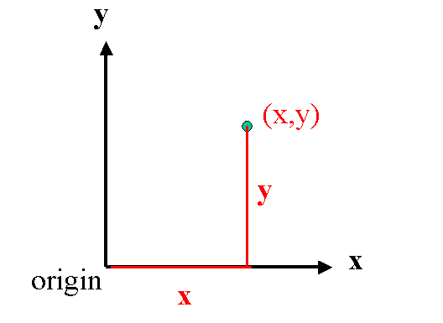
Projectile motion results when an object is subject to a single force: the constant force of gravity. In this case it is convenient to choose a Cartesian coordinate system with the y axis in the vertical direction (along a line pointing towards the center of the earth) and the x (horizontal) axis perpendicular to the y axis. If one position is represented by a pair of numbers, then the motion, which is a collection of positions, can be represented by a pair of functions
- x(t): the horizontal component of position as a function of time
- y(t): the vertical component of position as a function of time
The orientation of the coordinate system was selected so that the acceleration of the object is solely in one direction, the y direction. Consequently, there is no acceleration in the x or horizontal motion, and the x motion is described by the constant velocity equation
x(t) = x₀ + v_{0x} t
where x₀ is the horizontal component of the initial position and v_{0x} is the horizontal component of the initial velocity.
There is a constant acceleration in the vertical direction, and so the vertical motion is described by the constant acceleration equation
y(t) = y₀ + v_{0y} t - (1/2) g t²
where y₀ is the vertical component of the initial position, v_{0y} is the vertical component of the initial velocity and g=9.8 m/s², the constant acceleration due to gravity. The minus sign in the equation above is a consequence of implicitly selecting the positive y axis in the upward direction.
Experiment
- Remove the nut from the top of the bracket (shown below).


- Attach the bracket to the nut that is embedded in the launcher (see below). Notice the plumb line (little string with a weight on the end) and the protractor, they will allow us to determine the angle between the launcher and the horizontal.
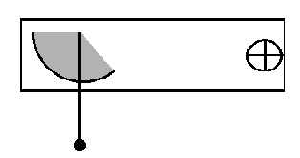

- Fix the launcher to a ring stand so that it is level (zero degrees from the horizontal), as shown below.
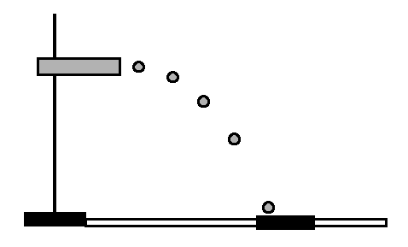
- Take some paper and lay it out in front of the ring stand. You may need a few sheets in order to make sure the various landing positions can be recorded.
- At the end of the launcher, there is a circle indicating the "launch position" (the initial position) of the projectile. Note the position on the floor or lab table (whichever you are using as the final horizontal level of the projectile motion) directly under the center of this circle. (You could use a plumb line, though not the one that comes attached.)
- Measure h the distance from the bottom of the launch position to the floor.
- Load the ball into the launcher. (There are different launcher settings; listen for the number of clicks as the ball is loaded into the launcher; try to make sure to use the same setting for all of your measurements.)
- Shoot the ball so that it lands on the paper. Note roughly where it lands and place a piece of carbon paper there. Make sure the ring-stand has not moved. Shoot the ball again. Now if you lift the carbon paper, there should be a mark on the paper underneath where the ball landed.
- Measure x the distance between the point on the paper directly below the launch position and the point where the ball landed on the paper.
- Repeat the above measurement two more times.
- Change the height and repeat the measurements. Do this for a total of six different heights. There should be at least 50 cm difference between your highest and lowest height. (There should be a total of eighteen measurements -- 6 heights times 3 readings per height. The column Stand. Dev. is standard deviation, use the Excel function =stdev(range)). Fill in the parentheses below with the unit (e.g. m for meter) corresponding to the values. (Since we know g=9.8 m/s², it is better for us to work in meters than in centimeters.)
Height  h  ( ) | Time of  flight  ( ) | Range x  trial 2  ( ) | Range x  trial 2  ( ) | Range x  trial 3  ( ) | Average  Range  ( ) | Stand.  Dev.  ( ) | Average  Velocity  ( )
Analysis.
- For a given height h, use g=9.8 m/s² for the acceleration due to gravity to calculate time of flight, the time the ball took in going from the launch position to the floor. Assuming there is no air resistance and no vertical component of the initial velocity, the above y equation becomes
0 = h - g t² / 2
- Using this time and the average x, calculate the average initial velocity.
x_{av} = v_{av} t
You should present these results along with your data in a table like that shown above.
- There is no reason to believe that the velocity given to the ball by the launcher is dependent on height. Comment on whether your velocities are consistent and height-independent.
- Plot h versus (average) x and fit to a power law. Compare the power you find to the theoretical prediction.
h = (g / 2 v²) x²;
The predicted power is square (2).
- Use your results to predict the range if the projectile were shot off the roof of Holroyd. Explain your reasoning, state any assumptions, etc.

