Standing waves on a string
When you throw a rock into a pool, the water is disturbed. The water is shifted away from its equilibrium position, the flat surface. This disturbance then moves in what we call a "traveling wave." If a wave happens upon an abrupt edge (like the pool wall), it will be reflected back. When there are two waves traveling in opposite directions, a possible outcome is a "standing wave."
In such a situation, the disturbance does not appear to move but rather just to oscillate in place. In fact, each point is undergoing periodic motion, all with the same period. While the periods are all same, the amplitude varies from point to point. But of course, two points that are very close must have nearly the same amplitude. There are special points, called nodes, which have no amplitude at all. Below is a picture of a standing wave where the different lines represent the wave at different times.
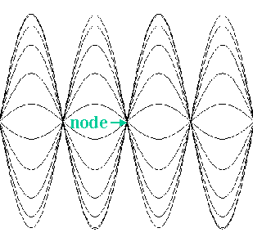
In addition to the notion of period T (the time required for the motion to repeat itself), with harmonic waves one has the concept of wavelength λ (the distance between two points that are undergoing identical motion). One has to be careful here. Our eyes tend to average what is happening over time. Two points that seem to be undergoing identical motion may in fact be undergoing opposite motion but when "time-averaged" appear to us to be identical. The speed of a wave is given by
v = λ / T
(When we talk about speed in a standing wave, we mean the speed of the two individual waves that make up the standing wave. We are not talking about "transverse velocity.") We can measure λ and T and determine this speed. If the wave in question is on a string, theory provides us with another expression for speed
v = (F / μ )^{1/2}
where F is the tension in the string and μ is the linear mass density (mass/length). One may see this equation written with a T for tension in place of F. In such a case, be careful not to confuse tension T with period T.
Experiment
- Plug in the power amplifier and connect it to the signal interface (use analog channel A). Turn it on.
- Connect the output of the amplifier to the speaker (two wires needed: one from the red terminal on the power amplifier to the speaker, the second from the speaker back to the black terminal of the power amplifier). One needs a complete circuit.
- Start up Data Studio and click on the image of the analog plug into analog channel A and choose "power amplifier." (Was the interface on before the computer?)
- A window labeled "Signal Generator" should appear. Choose an AC sine wave with amplitude 5.0 V and frequency 10 Hz. To change the frequency, click on the number under "Frequency", type the desired number and the hit Enter.
- Click on. The speaker should respond. Click off.
- Mount the speaker to a stand a meter or so away from the edge of the table, as shown below
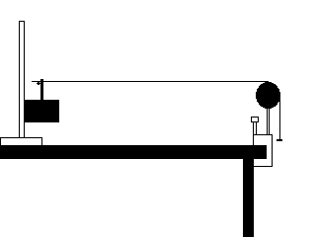
- Place the banana plug connector (red plastic thing with notch) so that it is sticking out of the top of the speaker.
- On the edge of the table mount a universal clamp and to it a pulley. (You can use a "smart" pulley, but there's no reason to plug it in.)
- Obtain the linear mass density (mass/length) of the thick stretchy cord. (Take the knots out the get a good measurement of the length.)
Thick stretchy cord
String mass  ( ) | String length  ( ) | linear mass density  ( )
- Then string it from the banana plug connector to the pulley and hang a hanger and a weight on the end.
- Secure the cord with a knot just outside the plug or tie it to the stand.
- Turn the signal generator on. By varying the frequency, you should be able to establish a standing wave pattern.
- Record the distance between nodes and the corresponding frequency.
- Find standing wave patterns with more nodes by increasing the frequency or ones with fewer nodes by decreasing the frequency. Try to find at least four different standing wave patterns.
Thick Stretchy Cord, Force ( )
Frequency  ( ) | Distance  between nodes  ( )
- Vary the mass on the hanger and hence the tension F. Find a standing wave pattern and measure the distance between nodes. (Whereas the principle of keeping one variable fixed while you vary another is usually a good idea, it doesn't work here. You will have to vary the frequency so you can find a good standing wave pattern.)
- For each tension find two standing wave patterns. Repeat the measurements for three more masses (five different tensions altogether). Record the tensions and node-to-node distances. (Don't forget to include the mass of the hanger.)
Thick stretchy cord
Force  ( ) | Frequency  ( ) | Distance  between nodes  ( )
Analysis
For the thick stretchy cord:
- For the first part in which the tension (force) was held fixed, make a plot of the distance between nodes versus 1/frequency. Fit the data to a straight line.
  - What is another name for 1/frequency?
  - How is the slope related to the speed of the wave in the string?
  - How does the speed compare to the v = (F / μ )^{1/2} prediction?
Thick stretchy cord
Slope from graph  ( ) | Speed from graph  ( ) | Speed from (F / μ )^{1/2}  ( ) | Percent Error
For the second part in which the tension was varied, use v = λ / T to calculate the speeds. Then make a plot of the speed versus tension. Fit it to a power law.
  - How does the wave's speed depend on the tension in the string?
  - How does this compare with the theoretical prediction?

