Part 2. Microinstructions.

Source: Digital Computer Electronics (Malvino and Brown)

In this section we will consider the steps involved in performing a simple instruction. We will use as our example the instruction for loading Accumulator A with a value stored at a particular address in the RAM. Recall that the instruction itself is also stored in the RAM. The steps are called timing states. In this example, there are six timing states.

Determine for the timing states of the Load Accumulator A instruction described below
- Which parts of the circuit are active? (Hint: the Controller/Sequencer is active whenever anything is happening and the Instruction Register is active during the execute cycle.)
- “Who’s driving the bus?”
- And who’s reading from the bus?

Load Accumulator A
Step | Active | Driving Bus | Reading bus
1 | Ctrl, PC, MAR | PC | MAR
2 | Ctrl, PC | -- | --
3 | Ctrl, MAR, Mem, MDR, IR | MDR | IR
4 | Ctrl, IR, MAR | IR | MAR
5 | Ctrl, IR, MAR, Mem, MDR, Acc | MDR | Acc
6 | Ctrl, IR, | -- | --

Note that the arrows are numbered. Fill in the table with the number of the arrows along which information is flowing for each of the timing steps.

Load Accumulator A
Step | Arrows along which information flows
1 | 4, 6
2 | --
3 | 7, 9, 10, 13
4 | 14, 12, 6
5 | 14 7, 9, 10, 15
6 | 14

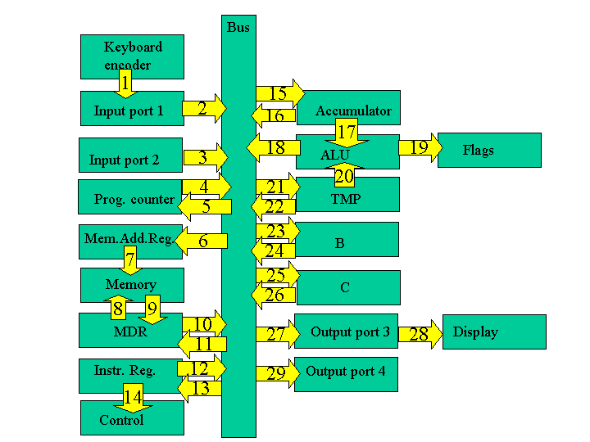

Load Accumulator A

The first few steps are the same for all instructions and are collectively known as the fetch cycle.

Fetch Cycle
- Address State: the value of the program counter (which recall is the address of line of the program to be performed) is put into memory address register.
- Increment State: the program counter is incremented, getting it ready for the next time.
- Memory State: the current line of the program is put into instruction register.

The remaining steps depend on the specific instruction and are collectively known as the execution cycle.

Execution Cycle
- Recall the instruction consisted of a load command and an address. A copy of the address is now taken over to the memory address register.
- The value at that address is loaded into Accumulator A.
- For the load command, there is no activity during the sixth step. It is known as a "no operation" step (a "no op" or "nop").

