Name:

PHYSICS 201
LAB 8

Part 1. Float conversions.

Express the following decimal number as a float. Use 1 bit for the sign, 23 bits for the significand (mantissa), 8 bits for the exponent. Do not use two’s complement. The exponent uses “biasing” – we will use 128.

-890.043

Start by expressing 890.043 as a “pseudo-fixed point number” using as many digits as necessary to represent the whole number 890 and represent the fractional part using the rest of the 23 places.

Next imagine moving the dot that separates whole number and fraction above to the very beginning. That will be our mantissa (we are not completely following the IEEE standard – that will prevent you from just finding some website that does the work for you). Take the number of places that you had to move the dot and add 128 (the bias); that result will be the exponent. The sign is simply 0 for a positive number or 1 for a negative number.

Sign
Mantissa
Exponent

Express the following float as a decimal number.
Sign
0
Mantissa
1 | 0 | 0 | 1 | 1 | 0 | 0 | 1 | 1 | 0 | 0 | 1 | 1 | 0 | 0 | 1 | 1 | 0 | 0 | 1 | 1 | 0 | 0
Exponent
1 | 0 | 1 | 0 | 1 | 0 | 1 | 0

Convert the mantissa to a decimal and divide by 2²³. That should yield a fraction that is more than a half and less than one.

Convert the exponent to decimal and subtract 128 (unbias) to obtain the power of 2.

(Sign) * (Mantissa Result) * 2^(Exponent Result)
Evaluate the above in a calculator.

Part 2. Ripple Counter from JK Flip Flops

Build the Ripple Counter shown below. Replace my version with yours and have a three showing (turn off the simulation when the counter reaches three).

Why is it called a ripple counter? And what problem could occur with it? (Hint look back at the ripple adder.)

What does the counter below count up to?

What does the switch above do?

Make the addition shown below.

What change in behavior results from this addition?

Part 3. The RS flip-flop.

Flip-flops serve as the elementary units for memory in digital systems. Two features are needed:
- The circuit must be able to “hold” either state (a high or low output) and not simply reflect the input at any given time.
- But in some circumstances, we must be able to change (to “set” and “reset”) the values.

One way to achieve this result is for flip-flops to have a feed-back feature.

There are two problems we must consider
- The R=1, S=1 input is disallowed.
- The output corresponding to the R=0, S=0 input depends on the initial state, and when first starting a simulation we don’t know what that state is.

Add to your circuit a battery and ground to establish high and low lines and switches leading from these lines to the R and S inputs as shown below.
Fill in the states Q and Q’ you find by flipping the switches in the order indicated below. Step 0 means that the setting of the switches when the system is first activated. Under type, put “set”, “reset” or “no change”.

R | S | Q | Q’ | Type
0 | 1
0 | 0
0 | 1
0 | 0
1 | 0
0 | 0
1 | 0
0 | 0

What happens if you start the simulation with R=0 and S=0?

What happens to the simulation when R=1 and S=1?

Part 4. IV curve of a diode using Electronics Workbench.

Using Electronics Workbench Multisim, construct the circuit below.

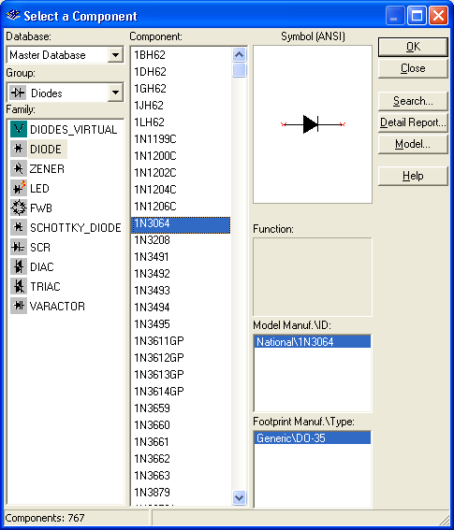

Note that a diode (found under the diode button, next to the basic (resistor) button) is represented as an arrow and a vertical line. Choose the 1N3064 diode. The arrow is on the anode side, and the cathode is on the vertical line side. Set the internal voltmeter resistance to 1000 MΩ and the internal resistance of the ammeter to 1 nΩ, so that the meters are very nearly ideal. Vary the battery voltage from 0.0 t0 1.0V, and record the voltage across the diode and the current through the diode

Voltage across battery | Voltage across diode  (in V) | Current through diode  (in mA) | Resistance across diode  ( Supply Units!)
0.0
0.1
0.2
0.3
0.4
0.5
0.6
0.7
0.8
0.9
1.0

Be sure that you convert all voltages to volts and all currents to milliamps. Next fill in the resistance column. Recall that the resistance is the ratio of Voltage to Current. Compare this to the result you found in Lab 1, Part 1, Number 13. Did the resistance across the resistor (in Lab 1) depend on voltage? Does the resistance of the diode (in this lab) depend on the voltage? Which is Ohmic? And which is non-Ohmic?

Part 5. Rectification

The current coming out of the wall socket is AC (alternating current), and a number of devices (including a computer) require DC current. A rectifier changes AC into DC. The circuit below is called a half-wave rectifier.

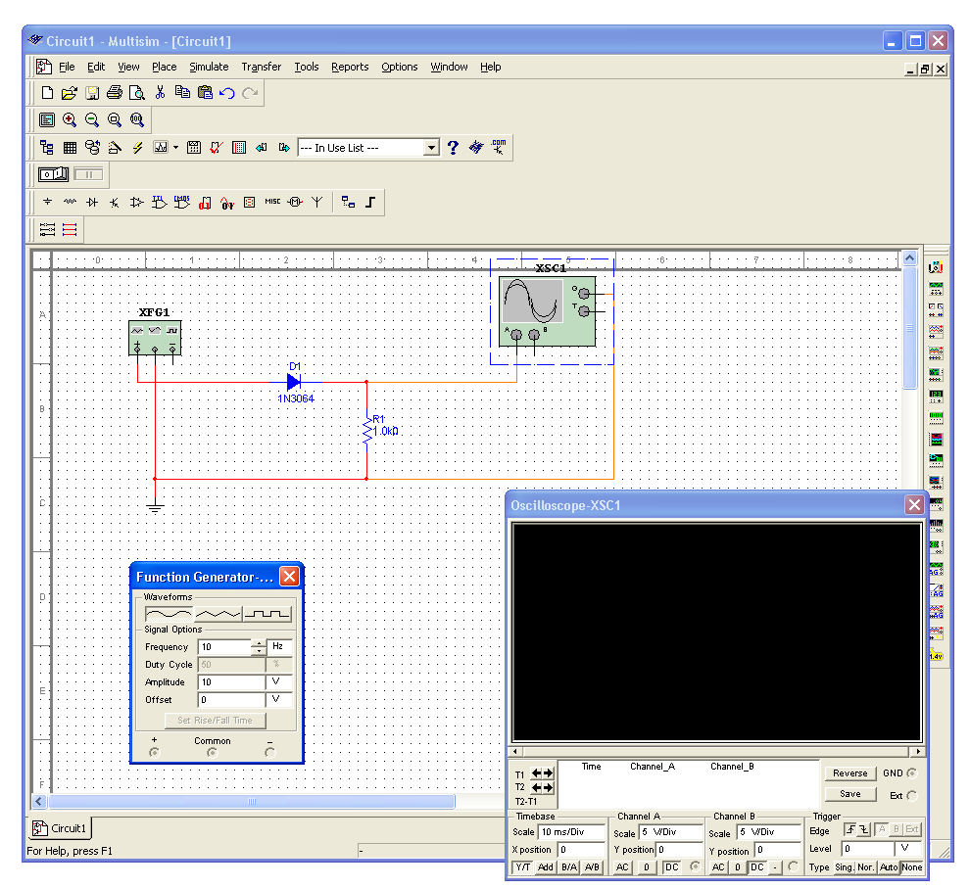
The box on the left is a function generator (found on the right, second from the top). Set its frequency to 10Hz. It will serve as an alternating voltage supply. The box with the sine wave is an oscilloscope (found on the right, fourth from the top). Think of the oscilloscope as a time-dependent voltmeter.

First build the circuit above without the diode. Run a simulation and place a copy of the expanded oscilloscope screen below. Then insert the diode into the circuit and repeat.

Finally build the circuit below, simulate it, and place a copy of its oscilloscope screen below. This circuit is known as a full-wave bridge rectifier. Explain the path taken by the current when the voltage is positive and when it is negative. (Draw a picture twice, indicate on the first the path taken by the current when the voltage at + is positive; indicate on the second the path taken by the current when the voltage at + is negative.)

