Name:_______________________

PHYSICS 201
LAB 9

Part 1. Building ROM.

The circuit shown below is a Poor Man’s version of ROM.

The following values have been “burned” into it.

B | A | Value
0 | 0 | 7
0 | 1 | D
1 | 0 | 6
1 | 1 | E

Build your own ROM and “burn” in the following values. Paste a copy of it below.

B | A | Value
0 | 0 | B
0 | 1 | F
1 | 0 | 5
1 | 1 | 3

Part 2. Microinstructions.

Source: Digital Computer Electronics (Malvino and Brown)

In this section we will consider the steps involved in performing a simple instruction. We will use as our example the instruction for loading Accumulator A with a value stored at a particular address in the RAM. Recall that the instruction itself is also stored in the RAM. The steps are called timing states. In this example, there are six timing states.

Determine for the timing states of the Load Accumulator A instruction described below
- Which parts of the circuit are active? (Hint: the Controller/Sequencer is active whenever anything is happening and the Instruction Register is active during the execute cycle.)
- “Who’s driving the bus?”
- And who’s reading from the bus?

Load Accumulator A
Step | Active | Driving Bus | Reading bus
1
2
3
4
5
6

Note that the arrows are numbered. Fill in the table with the number of the arrows along which information is flowing for each of the timing steps.

Load Accumulator A
Step | Arrows along which information flows
1
2
3
4
5
6

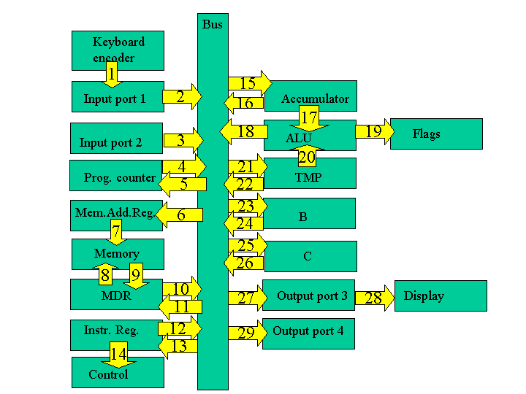

Load Accumulator A

The first few steps are the same for all instructions and are collectively known as the fetch cycle.

Fetch Cycle
- Address State: the value of the program counter (which recall is the address of line of the program to be performed) is put into memory address register.
- Increment State: the program counter is incremented, getting it ready for the next time.
- Memory State: the current line of the program is put into instruction register.

The remaining steps depend on the specific instruction and are collectively known as the execution cycle.

Execution Cycle
- Recall the instruction consisted of a load command and an address. A copy of the address is now taken over to the memory address register.
- The value at that address is loaded into Accumulator A.
- For the load command, there is no activity during the sixth step. It is known as a "no operation" step (a "no op" or "nop").

Part 2. The add command

Let us repeat the above procedure for an add instruction. This instruction adds a value stored at a particular address in the RAM to whatever is in Accumulator A and places that answer back in Accumulator A. Recall that the instruction itself is also stored in the RAM.

The first few steps are the same for all instructions and are collectively known as the fetch cycle.

Fetch Cycle (the first three steps are the same as abovesame as above)

Execution Cycle
- Recall the instruction consists of an add command and the address of the number to be added. A copy of the address is now taken over to the memory address register.
- The value at that address is loaded into TMP.
- The values in Accumulator A and TMP are added and the result is sent to Accumulator A. You may wonder why when the result is placed in the Accumulator A, it is not again added to TMP (producing what is called a "racing accumulator"). The cure for this potential problem is edge clocking. Edge clocking makes it possible to load only during a very short interval of time. It is also possible to activate different processes on different edges.

Add
Step | Active | Driving Bus | Reading bus
1
2
3
4
5
6

Add
Step | Arrows along which information flows
1
2
3
4
5
6
Recall that in lecture we distinguished load, load immediate and load indirect commands. There would similarly be distinctions between add, add immediate and add indirect commands.

Part 3. Beginning Transistors. Build the circuit below in Electronics Workbench. The item we have not seen before is an npn transistor (found under Transistors, which are next to the diodes). There are many types of transistors, but the basic principle is the same for all of them. Note that the transistor is a three-terminal device. In the circuit below, the terminal on the top is called the collector; the terminal in the middle and to the left is called the base; and the terminal bottom on the bottom is called the emitter. The collector should be at a higher (more positive) voltage than the emitter.

Vary the voltage VBB and fill in the table below. (If the simulation bombs out at any voltage say VBB= 0.7, then adjust the voltage to 0.71.)

VBB (V) | VBE (V) | IB (mA) | VCE (V) | IC (mA) | VCE/IC  ( ) | IC/IB
0.1 | 0.1 | 0.000014 | 9.999 | 0.001776 | 5630 | 126.9
0.2 | 0.2 | 0.000028 | 9.999 | 0.001776 | 5630 | 63.4
0.3
0.4
0.5
0.6
0.7 | 0.635 | 0.006439 | 8.582 | 1.419 | 6.048 | 220
0.8
0.9
1.0
1.1
1.2 | 0.689 | 0.051 | 0.245 | 9.756 | 0.02511 | 191.3
1.3
1.4
1.5
1.6
1.7
1.8
1.9
2.0

If you were going to use the data above to identify three regions: on, transition and off, where would you say those regions were?

